# Prediction of 90-day mortality after major surgery made simpler: An analysis of different comorbidity measures based on 38,735 patients from the Swedish Hip Arthroplasty Register

Anne Garland 1,2,3, MD, Szilard Nemes2, 4, Erik Bülow2, 4, PhD, Göran Garellick 2,4, MD, PhD, Nils P. Hailer 1,2, MD

1 Department of Orthopaedics, Institute of Surgical Sciences, Uppsala University Hospital, Uppsala, Sweden

2 Swedish Hip Arthroplasty Register, Gothenburg, Sweden

3 Department of Orthopaedics, Visby Hospital, Visby, Sweden

4 Department of Orthopaedics, Institute of Clinical Sciences, The Sahlgrenska Academy, University of Gothenburg, Gothenburg, Sweden

Correspondence:anne.l.garland@gmail.com, Tel: +46-498-26 80 00, Orthopeadic Department, Visby Hospital, St Göransgatan 10, 621 84 Visby, Sweden

[nils.hailer@surgsci.uu.se](mailto:nils.hailer@surgsci.uu.se)

[szilard.nemes@registercentrum.se](mailto:szilard.nemes@registercentrum.se)

Erik.bülow@registercentrum.se

goran.garellick@registercentrum.se

# Abstract

## Objective

To investigate the early mortality after THA prediction capacity of easily accessible data that are routinely collected in daily clinical practice compared to commonly used comorbidity coding algorithms ie the Elixhauser score, Charlson Comorbidity Index (CCI), and the prescription-based RxRiskV.

## Design

Nationwide prospective observational cohort study.

## Setting

Database combining the Swedish Hip Arthroplasty Registry, the Swedish Patient Registry (the National Board of Health and Welfare), and data from Statistics Sweden.

## Participants

38,735 patients who received a THA due to primary osteoarthritis between 2008 and 2012.

## Primary Outcome Measure

Death within 90 days after surgery.

## Results

Unadjusted cumulative 90-day survival was 99.7 (95% confidence interval: 99.68 to 99.78) and the number of deaths within 90 days was 109. Best predictive performance for 90-day mortality was found for a model combining age, gender, presence of heart infarction, renal disease, and American Society of Anaesthesiologists (ASA) grade (c=0.80). The established, more complex comorbidity measures RxRiskV Score(c= 0.66), CCI (c=0.64), and Elixhauser (c=0.62) all had inferior predictive performance, while ASA grade alone had a c-statistic of 0.70.

## Conclusion

A less demanding comorbidity measure based on age, gender, two important comorbidities, and ASA grade, is better at predicting early postoperative mortality after THA than commonly used comorbidity measures that depend on access to extensive information on ICD-codes or medication prescription. This novel tool could simplify research on mortality after surgical interventions and may result in easy-to-use risk estimators for daily clinical practice.

# Introduction

The presence of comorbidities is associated with increased postoperative mortality(1), risk of revision(2, 3) and inferior patient-reported outcome after total hip arthroplasty (THA).(3, 4) In research settings, comorbidity is commonly measured using multi-facetted diagnosis- or prescription-based coding algorithms.(5) The ability of three frequently used coding algorithms (Charlson Comorbidity Index (CCI), Elixhauser Score, and RxRiskV) to predict mortality after total hip arthroplasty (THA) and total knee arthroplasty (TKA) was recently evaluated.(6) These complex comorbidity measures are based on the availability of hospital episode statistics including ICD-codes, or detailed information on drug prescriptions prior to surgery. Oftentimes, such databases can only be created by combining several population-based registries, raising both ethical and practical concerns. Repeated modifications of the weighting of certain items contained in the comorbidity measures, and revalidations of the scores have been necessary.(7-11) This has resulted in numerous variations of several scores (ie Charlsons comorbidity index according to Charlson, Deyo or Quan), and hence uncertainty regarding the interpretation of and comparison between different studies. In the context of trauma some prediction tools are suggested, and it is possible to reduce the number of variables without loss of predictive power.(12) Several risk prediction tools of various degrees of complexity have been introduced in the context of THA surgery, but none has been broadly accepted.(13)

An easily applicable tool with few dimensions is thus needed, both in research and in clinical practice. In the present study we therefore aimed to investigate whether the use of easily accessible, routinely collected data is an alternative to complex coding algorithms in estimating the risk of early postoperative mortality after THA.

# Methods

## Study design and study population

We performed a nationwide prospective observational cohort study (Figure 1). Primary outcome measure was 90-day mortality, the secondary outcome measure was one-year mortality. Patients registered in the Swedish Hip Arthroplasty Register (SHAR) who received a primary THA due to primary osteoarthritis between 2008 and 2012 were included.

Follow-up started on the date of surgery and ended on the day of death, emigration, or December 31st 2012, whichever came first. Only the first surgery was accounted for in bilaterally operated patients in order to avoid dependency issues. Patients were excluded if a second THA surgery was performed within 12 months after the first THA surgery. Information on age, gender, body mass index (BMI), diagnosis codes and prescriptions registered within one year prior to surgery, and socioeconomic background was included in order to calculate and compare the comorbidity measures described below.

## Data sources

***The SHAR*** collects information on all THA procedures performed in Sweden, it has a completeness of 98% and has been validated repeatedly.(14-16) ***Statistics Sweden*** is a state-owned registry collecting demographic and socioeconomic information on the Swedish population. ***The Swedish National Patient Register*** contains information on diagnosis codes and dates of admissions and discharge for all individuals in Sweden, and its positive predictive value is estimated around 90±5%.(17) ***The Drug Register*** contains information on all collected prescriptions in Sweden. Based on the ten-digit personal identity number that all Swedish citizens are assigned at birth or immigration, linkage of information from the databases described above can be performed.

## Definitions

***The Charlson Comorbidity Index*** (CCI) is a diagnose-based coding algorithm.(18) It was developed through defining numerous clinical conditions and assessing their relevance in the prediction of one-year mortality. Each of the 19 comorbidities was then assigned a weighted score based on their relevance in prediction of one-year all-cause mortality. In the present study the original weighting of the Deyo-modification(8) of the index and the revised weighting according to Quan were both investigated. (9, 18)

***The Elixhauser Score*** is a diagnose-based coding algorithm. (19) The Elixhauser Score is more detailed than the CCI, with 30 categories included in the original algorithm. In the present study the weighting according to van Walraven was used.(11)

***The RxRiskV Score*** is a prescription-based coding algorithm.(20, 21) It has been argued that a prescription-based measure would be more reliable than a diagnosed based measure.(22, 23)

***The American Society of Anaesthesiologists*** (ASA) physical status classificationis a six-category physical status evaluation system.(24) Information on ASA grade was introduced in the SHAR in 2008, which is why our study period begins that year. ASA grade is routinely assessed pre-operatively in most developed countries. However, ASA grade has not been validated as a predictor of 90-day mortality after THA, and ASA grade is known to have a high degree of internal variability.(25) ASA grade has previously been compared to the CCI, but not with respect to mortality after THA.(26, 27)

## Statistics

We adhered to the guidelines on statistical analyses of register data.(28, 29) Means, medians and ranges were used to describe continuous data. 95% confidence intervals (CI) described estimation uncertainty. Categorical data were investigated by cross-tabulation and the Chi-square test. The Kaplan-Meier method was used to estimate unadjusted cumulative survival. In order to calculate unadjusted and adjusted odds ratios (OR) with CI logistic regression models were fitted, with adjustment for relevant confounders (age, gender, BMI (Body Mass Index), type of hospital, fixation method, comorbidity, and socioeconomic status). Continuous variables were kept continuous in order not to weaken the precision of the statistical analyses.(30)

ASA, Elixhauser, CCI, and RxRiskV respectively were combined with age, gender, and BMI in four separate logistic regression models. Based on lower bounds of CI being larger than one, all relevant candidate predictors from the separate dimensions of the comorbidity algorithms were identified. The performance of the logistic regression models was evaluated by its discrimination capacity using c-statistics. The c-statistic represents the area under the curve (AUC in the plotted ROC [receiver operated characteristic] graph) and stands for the degree of predictability. All relevant candidate predictors were combined in a larger model together with age, gender, BMI, and ASA. Predictors were excluded from the model one at a time using backwards elimination until the combination of predictors with the highest degree of predictability was found. We then reinserted the excluded predictors one at a time to see whether this would strengthen the degree of predictability. No imputation for missing data was performed.

## Ethical approval

All patients registered in the SHAR are given the choice not to participate in the registry or associated research. Informed consent is not mandatory according to the Swedish Patient Data Law from 2009. Ethical approval for the present study was obtained from the Regional Ethical Review Board in Gothenburg (2013: 360-13).

# Results

Study participants

After the exclusion process described above (Figure 1) 38,735 individuals with an age between 18 and 100 years who hade undergone THA due to primary OA were eligible for analysis. The highest proportion of patients with multiple comorbidities (ie, three or more) was identified by the RxRiskV measure (69.9%; Table 1).

## Ninety-day mortality after THA

Unadjusted cumulative 90-day survival was 99.7 (CI 99.68 to 99.78) and the number of deaths during this period was 109. We found that higher age (OR 1.1 [CI 1.09-1.14]) and male gender were associated with an increased risk of death (OR for female gender: 0.5 [CI 0.37-0.79]). Patients with a higher degree of comorbidity according to the CCI, the Elixhauser score, and the RxRiskV score had an increased risk of 90-day mortality compared with patients with a lower score(Table 2 and 3). Among the investigated socioeconomic background variables only the marital status of widows (-ers) was statistically significantly associated with an increased risk of 90-day mortality (adjusted OR 2.6 [CI 1.67-3.93]). Unadjusted and adjusted ORs for 90-day mortality with 95% confidence intervals are presented in Table 2. Exploratory analyses of the excluded 151 patients with an ASA grade above 3 showed that 149 were classified as ASA 4, 2 as ASA 5, and none as ASA 6. 27 individuals with ASA grade 4 to 6 (18%) died during the study period.

## A set of easily accessible data is a better predictor of early mortality after THA surgery than complex coding algorithms

We found that the combination of age, gender, presence of heart infarction and renal disease, and ASA grade was the best predictor of both 90-day mortality (c=0.80) and one-year mortality (Figure 2 and Supplementary Figure 1). Removing ASA from the model substantially weakened the predictive power. Introduction of socioeconomic variables such as education level and marital status into the multivariable regression model only marginally increased its predictive power (Table 2). Adding information on BMI to the model did not strengthen the predictive power (Supplementary Table 1).

The ASA classification alone had a better predictive strength for 90-day mortality (c=0.70) than the more complex comorbidity measures CCI, Elixhauser score, and RxRiskV score (See Figure 2). The total Elixhauser score, CCI and RxRiskV Score were better at predicting 90-day mortality than any of its separate dimensions investigated individually (see Table 3A-C and Figure 2). The prescription-based RxRiskV Score was better at predicting 90-day mortality than the diagnosis-based comorbidity measures (CCI and Elixhauser Score), with a c-statistic of 0.66.

# Discussion

In this nationwide prospective observational study we intended to compare the performance of a set of easily accessible data that are routinely collected in daily clinical practice with complex comorbidity coding algorithms (ie CCI, Elixhauser Score and RxRiskV). The best predictive strength was found for a relatively simple model including age, gender, presence of cardiac infarction and renal disease during the last 12 months prior to THA surgery, and ASA grade (c=0.81). This model was also better than the above-mentioned comorbidity measures at predicting one-year mortality (Supplementary Figure 1 and Supplementary Table 3).

Comorbidities are known to influence the outcome after THA.(2-4) In order to assess the effect of comorbidity on early mortality after THA different coding algorithms have been proposed. The coding algorithms are complex, and some demand a merge of information on ICD-codes and/or medication prescriptions from several data sources. These coding algorithms are not used in clinical settings since the administrative burden associated with identifying some 30 ICD- or ATC-codes for every patient is unrealistic. Thus, comorbidity measures based on patient administrative data are accessible to researchers, but — even then —observational study designs are hampered by limitations such as incompleteness and inaccuracy of coding.(5)

In this present study we found that the prescription-based RxRiskV Scoreperformed better than the diagnosis-based comorbidity measures CCI and Elixhauser Score in predicting 90-day mortality. The original CCI was somewhat better than the Elixhauser Score in predicting 90-day mortality. This differs from earlier findings by Inacio et al where the RxRiskV did not perform as well as the CCI and the Elixhauser Score, and where the c- statistics were generally higher than in our study.(6) Such dissimilarities could be explained by differences in study population caracteristics and that we only included diagnoses and prescriptions registered one year prior to surgery. Overall, the predictive strength of all investigated diagnose- or prescription-based comorbidity measures was better than the included dimensions investigated separately. To put it differently, in terms of predicting mortality, each comorbidity measure was an improvement over the separate items included in each measure.

We also found that the ASA classification alone was better at predicting both 90-day and one-year mortality than the more complex coding algorithms, with a c- statistic of 0.70. The ASA classification has been repeatedly compared to the CCI, but no consensus as to which one is superior has been reached, and, to our knowledge, such comparisons have not been performed on a THA population.(26, 27) Individuals with an ASA grade of 4 to 6 were excluded from our study population since those categories describe severe disease, moribund and brain-dead individuals. Within the present setting of early mortality after THA surgery it can be questioned whether the classification of individuals receiving THA as ASA grade 4 or above was correct, and — if it was — whether these patients should ever have received a THA. We thus excluded this small subgroup with very high mortality, but supplementary analyses including this subgroup only marginally changed the estimates obtained previously (data not shown).

Obesity is generally known to be associated with a higher risk of morbidity and all-cause mortality. (31) However, previous studies on primary THA cohorts have not indicated a higher risk of mortality in obese patients, a result that is confirmed in our study (Supplementary Table 1).(32) An explanation could be that obese patients selected for THA are comparably healthy.

Risk prediction may be useful in the process of patient selection prior to surgery, in the preoperative risk management including a review of current medications, and in perioperative anaesthesia management. Our results indicate that the risk of early postoperative mortality after primary THA could be assessed by a relatively simple prediction model. Development of future prediction tools for this group of patients could beneficially be based on a reduced number of included predictors without losing predictive power.(12, 13)

## Strengths and limitations

A strength of this study is its nationwide design with a large cohort of primary THA patients with a reasonable number of events, rendering our estimates relatively precise. Our sources of data are highly valid, and the proportion of missing data in our cohort was low. (14-17) Limitations to this study are the potential biases at different levels that are commonly associated with observational data. Selection bias is an issue in this study, since patients who died on the table during attempted THA surgery may not have been reported to the SHAR, but, judging from clinical experience, such events are extremely uncommon in a population of patients scheduled for elective THA surgery due to osteoarthritis.

It is important to distinguish between explanatory observational research and attempts at predicting individual events such as early mortality after surgical interventions. The combination of parameters in the best-performing model described in the present study may serve as a predictor of mortality on an individual level, but that would need to be validated in a different sample of individuals. Since this has not yet been done we cannot extrapolate our findings to prediction models in a clinical setting, but aim at performing such additional studies.

Our results indicate a less complex comorbidity measure consisting of easily accessible data that are routinely collected in daily clinical practice is superior to some of the commonly used diagnose- or prescription-based coding algorithms when predicting mortality after a common surgical intervention. It would be interesting to evaluate the ability of our novel set of parameters to predict adverse events and revision rates.

## Conclusion

Our results derived from a nationwide cohort study indicate that a less demanding comorbidity measure—the combination of age, gender, presence of heart infarction and renal disease and ASA grade—is better at predicting early postoperative mortality after major orthopaedic surgery than comorbidity measures based on more complex coding algorithms.

## Contribution of authors

AG, NH: initiated the study and managed the ethical review board application. EB, SN and AG performed the statistical analyses. GG: Assisted in preparing the review board application. AG drafted the manuscript. AG, EB, SN, NH and GG took part in designing the study and editing the manuscript.

# ”What this paper adds”-box

## What is already known on this subject:

A higher comorbidity burden is associated with increased early mortality after major surgery. Established comorbidity measures rely on complex coding algorithms of data on ICD- and/or prescription codes, and thus they are cumbersome instruments in research and impossible to use in clinical practice.

## What this study adds:

The combination of age, gender, presence of heart infarction and renal disease, and ASA grade was a better predictor of mortality after primary THA than the more complex comorbidity measures Charlson Comorbidity Index, Elixhauser Score and RxRiskV. Thus, a five-item instrument that is easily available in a clinical setting could both simplify research on mortality after major surgery and be developed into a simple risk prediction tool.

# Bibliography

1. Garland A, Gordon M, Garellick G, Karrholm J, Skoldenberg O, Hailer NP. Risk of early mortality after cemented compared with cementless total hip arthroplasty: a nationwide matched cohort study. The bone & joint journal. 2017 Jan;99-B(1):37-43. PubMed PMID: 28053255.

2. Inacio MC, Pratt NL, Roughead EE, Graves SE. Using Medications for Prediction of Revision after Total Joint Arthroplasty. The Journal of arthroplasty. 2015 Dec;30(12):2061-70. PubMed PMID: 26190569.

3. Gordon M, Stark A, Skoldenberg OG, Karrholm J, Garellick G. The influence of comorbidity scores on re-operations following primary total hip replacement: comparison and validation of three comorbidity measures. The bone & joint journal. 2013 Sep;95-B(9):1184-91. PubMed PMID: 23997129. Epub 2013/09/03. eng.

4. Hofstede SN, Gademan MG, Vliet Vlieland TP, Nelissen RG, Marang-van de Mheen PJ. Preoperative predictors for outcomes after total hip replacement in patients with osteoarthritis: a systematic review. BMC musculoskeletal disorders. 2016;17:212. PubMed PMID: 27184266. Pubmed Central PMCID: 4869370.

5. Bozic KJ, Bashyal RK, Anthony SG, Chiu V, Shulman B, Rubash HE. Is administratively coded comorbidity and complication data in total joint arthroplasty valid? Clinical orthopaedics and related research. 2013 Jan;471(1):201-5. PubMed PMID: 22528384. Pubmed Central PMCID: 3528892.

6. Inacio MC, Pratt NL, Roughead EE, Graves SE. Evaluation of three co-morbidity measures to predict mortality in patients undergoing total joint arthroplasty. Osteoarthritis and cartilage / OARS, Osteoarthritis Research Society. 2016 Oct;24(10):1718-26. PubMed PMID: 27188683.

7. Sundararajan V, Henderson T, Perry C, Muggivan A, Quan H, Ghali WA. New ICD-10 version of the Charlson comorbidity index predicted in-hospital mortality. Journal of clinical epidemiology. 2004 Dec;57(12):1288-94. PubMed PMID: 15617955.

8. Deyo RA, Cherkin DC, Ciol MA. Adapting a clinical comorbidity index for use with ICD-9-CM administrative databases. Journal of clinical epidemiology. 1992 Jun;45(6):613-9. PubMed PMID: 1607900.

9. Quan H, Li B, Couris CM, Fushimi K, Graham P, Hider P, et al. Updating and validating the Charlson comorbidity index and score for risk adjustment in hospital discharge abstracts using data from 6 countries. Am J Epidemiol. 2011 Mar 15;173(6):676-82. PubMed PMID: 21330339. Epub 2011/02/19. eng.

10. Cleves MA, Sanchez N, Draheim M. Evaluation of two competing methods for calculating Charlson's comorbidity index when analyzing short-term mortality using administrative data. Journal of clinical epidemiology. 1997 Aug;50(8):903-8. PubMed PMID: 9291875.

11. van Walraven C, Austin PC, Jennings A, Quan H, Forster AJ. A modification of the Elixhauser comorbidity measures into a point system for hospital death using administrative data. Medical care. 2009 Jun;47(6):626-33. PubMed PMID: 19433995.

12. Gerdin M, Roy N, Khajanchi M, Kumar V, Fellander-Tsai L, Petzold M, et al. Validation of a novel prediction model for early mortality in adult trauma patients in three public university hospitals in urban India. BMC emergency medicine. 2016;16:15. PubMed PMID: 26905408. Pubmed Central PMCID: 4763419.

13. Manning DW, Edelstein AI, Alvi HM. Risk Prediction Tools for Hip and Knee Arthroplasty. The Journal of the American Academy of Orthopaedic Surgeons. 2016 Jan;24(1):19-27. PubMed PMID: 26604220.

14. Soderman P, Malchau H, Herberts P, Johnell O. Are the findings in the Swedish National Total Hip Arthroplasty Register valid? A comparison between the Swedish National Total Hip Arthroplasty Register, the National Discharge Register, and the National Death Register. The Journal of arthroplasty. 2000 Oct;15(7):884-9. PubMed PMID: 11061449.

15. Swedish Hip Arthroplasty Register (SHAR). The Annual Report 2014. <http://www.shpr.se/>.

16. Soderman P, Malchau H, Herberts P, Zugner R, Regner H, Garellick G. Outcome after total hip arthroplasty: Part II. Disease-specific follow-up and the Swedish National Total Hip Arthroplasty Register. Acta Orthop Scand. 2001 Apr;72(2):113-9. PubMed PMID: 11372940.

17. Ludvigsson JF, Andersson E, Ekbom A, Feychting M, Kim JL, Reuterwall C, et al. External review and validation of the Swedish national inpatient register. BMC public health. 2011;11:450. PubMed PMID: 21658213. Pubmed Central PMCID: Pmc3142234. Epub 2011/06/11. eng.

18. Charlson ME, Pompei P, Ales KL, MacKenzie CR. A new method of classifying prognostic comorbidity in longitudinal studies: development and validation. J Chronic Dis. 1987;40(5):373-83. PubMed PMID: 3558716.

19. Elixhauser A, Steiner C, Harris DR, Coffey RM. Comorbidity measures for use with administrative data. Medical care. 1998 Jan;36(1):8-27. PubMed PMID: 9431328.

20. Fishman PA, Goodman MJ, Hornbrook MC, Meenan RT, Bachman DJ, O'Keeffe Rosetti MC. Risk adjustment using automated ambulatory pharmacy data: the RxRisk model. Medical care. 2003 Jan;41(1):84-99. PubMed PMID: 12544546.

21. Sloan KL, Sales AE, Liu CF, Fishman P, Nichol P, Suzuki NT, et al. Construction and characteristics of the RxRisk-V: a VA-adapted pharmacy-based case-mix instrument. Medical care. 2003 Jun;41(6):761-74. PubMed PMID: 12773842.

22. Iezzoni LI. Assessing quality using administrative data. Annals of internal medicine. 1997 Oct 15;127(8 Pt 2):666-74. PubMed PMID: 9382378.

23. Johnson ML, El-Serag HB, Tran TT, Hartman C, Richardson P, Abraham NS. Adapting the Rx-Risk-V for mortality prediction in outpatient populations. Medical care. 2006 Aug;44(8):793-7. PubMed PMID: 16862043.

24. Saklad M. Grading of patients for surgical procedures. Anesthesiology. 1941;2:281-4.

25. Haynes SR, Lawler PG. An assessment of the consistency of ASA physical status classification allocation. Anaesthesia. 1995 Mar;50(3):195-9. PubMed PMID: 7717481.

26. Kork F, Balzer F, Krannich A, Weiss B, Wernecke KD, Spies C. Association of comorbidities with postoperative in-hospital mortality: a retrospective cohort study. Medicine. 2015 Feb;94(8):e576. PubMed PMID: 25715258. Pubmed Central PMCID: 4554144.

27. Whitmore RG, Stephen JH, Vernick C, Campbell PG, Yadla S, Ghobrial GM, et al. ASA grade and Charlson Comorbidity Index of spinal surgery patients: correlation with complications and societal costs. The spine journal : official journal of the North American Spine Society. 2014 Jan;14(1):31-8. PubMed PMID: 23602377.

28. Ranstam J, Karrholm J, Pulkkinen P, Makela K, Espehaug B, Pedersen AB, et al. Statistical analysis of arthroplasty data. I. Introduction and background. Acta orthopaedica. 2011 Jun;82(3):253-7. PubMed PMID: 21619499. Pubmed Central PMCID: 3235301.

29. Ranstam J, Karrholm J, Pulkkinen P, Makela K, Espehaug B, Pedersen AB, et al. Statistical analysis of arthroplasty data. II. Guidelines. Acta orthopaedica. 2011 Jun;82(3):258-67. PubMed PMID: 21619500. Pubmed Central PMCID: 3235302.

30. Altman DG, Royston P. The cost of dichotomising continuous variables. Bmj. 2006 May 6;332(7549):1080. PubMed PMID: 16675816. Pubmed Central PMCID: 1458573.

31. Must A, McKeown NM. The Disease Burden Associated with Overweight and Obesity. In: De Groot LJ, Beck-Peccoz P, Chrousos G, Dungan K, Grossman A, Hershman JM, et al., editors. Endotext. South Dartmouth (MA)2000.

32. Wallace G, Judge A, Prieto-Alhambra D, de Vries F, Arden NK, Cooper C. The effect of body mass index on the risk of post-operative complications during the 6 months following total hip replacement or total knee replacement surgery. Osteoarthritis and cartilage / OARS, Osteoarthritis Research Society. 2014 Jul;22(7):918-27. PubMed PMID: 24836211.

**Table 1:** Baseline demographic information on the study population 2008-2012.



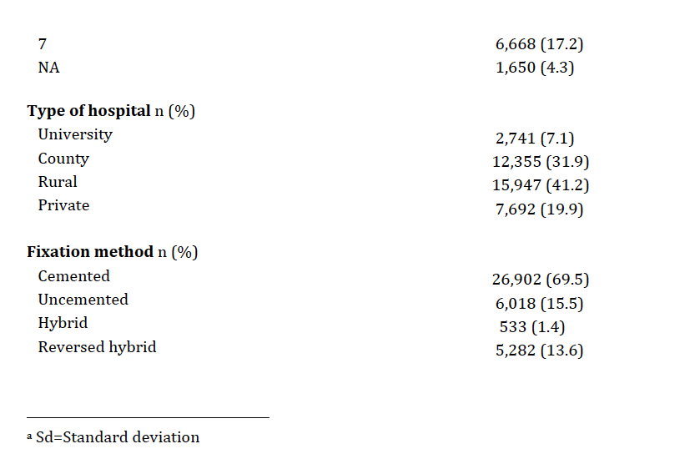

**Table 2.** Unadjusted and adjusted OR for 90-day mortality with 95% confidence intervals. The adjusted ORs for ASA, Elixhauser, CCI and RxRiskV were derived from four separate models with adjustment for age, gender, BMI, type of hospital, fixation method, level of education and marital status.



**Table 3 A-C:** 90-day mortality crude OR with 95% CI and c-statistic for the three investigated coding algorithms and their included dimensions. A Elixhauser Score, B Charlson Comorbidity Index and C RxRiskV.





**C:**

|  |  |  |  |
| --- | --- | --- | --- |
| **RxRiskV** | **OR** | **CI (95%)** | **c-statistic** |
|  |  |  |  |
| Alcohol dependence | 2.7 | 0.38- 19.55 | 0.50 |
| Allergies | 0.7 | 0.32- 1.36 | 0.52 |
| Anti coagulation therapy | 1.7 | 0.98- 3.02 | 0.53 |
| Anti platelet therapy | 2.0 | 1.37- 2.97 | 0.57 |
| Anxiety | 2.2 | 1.27- 3.80 | 0.54 |
| Arrhythmia | 2.5 | 1.01- 6.11 | 0.51 |
| Benign prostate hypertrophy | 1.3 | 0.50-3.66 | 0.51 |
| Bipolar disorder | 0.4 | 1.62- 1.87 | 0.51 |
| Chronic heart failure | 2.3 | 1.61-3.51 | 0.61 |
| Dementia | - | - | 0.50 |
| Depression | 0.7 | 0.37- 1.37 | 0.52 |
| Diabetes | 2.2 | 1.31- 3.62 | 0.54 |
| End stage renal disease | 7.5 | 2.75- 20.66 | 0.52 |
| Epilepsy | 1.7 | 0.64- 4.72 | 0.51 |
| Gastric oesophageal reflux disorder | 0.8 | 0.48- 1.25 | 0.52 |
| Glaucoma | 1.4 | 0.65-3.01 | 0.51 |
| Gout | 2.3 | 1.01-5.28 | 0.52 |
| Hepatitis C | 1.5 | 0.36- 5.90 | 0.50 |
| HIV | - | - | 0.50 |
| Hyperkalaemia | - | - | 0.50 |
| Hyperlipidaemia | 1.5 | 0.98- 2.17 | 0.54 |
| Hypertension | 2.4 | 1.61-3.45 | 0.61 |
| Hyperthyroidism | 1.0 | 0.53- 2.00 | 0.50 |
| Angina | 4.0 | 2.53- 6.48 | 0.57 |
| Ischaemic heart disease hypertension | 3.7 | 2.45- 5.65 | 0.66 |
| Inflammatory bowel disease | 4.3 | 1.57- 11.73 | 0.51 |
| Liver failure | 3.4 | 1.90- 6.07 | 0.54 |
| Malignancies | 2.1 | 0.29- 15.26 | 0.50 |
| Malnutrition | - | - | 0.50 |
| Migraine | - | - | 0.51 |
| Osteoporosis, Paget | 2.0 | 1.00- 3.96 | 0.52 |
| Pain | 1.3 | 0.92- 1.95 | 0.54 |
| Inflammation pain | 0.4 | 0.27- 0.58 | 0.61 |
| Pancreatic insufficiency | - | - | 0.50 |
| Parkinson disease | 1.3 | 0.42- 5.19 | 0.50 |
| Psoriasis | 2.1 | 0.51-8.52 | 0.51 |
| Psychotic illness | 2.5 | 0.79- 7.87 | 0.51 |
| Chronic airways disease | 1.3 | 0.75- 2.31 | 0.51 |
| Smoking cessation | - | - | 0.50 |
| Steroid responsive diseases | 1.6 | 0.95- 2.75 | 0.53 |
| Transplant | 0 | 0- 253.43 | 0.50 |
| Tuberculosis | - | - | 0.50 |
| RxRiskV index | 1.2 | 1.13-1.29 | 0.66 |

**Figure 1:** Flowchart.

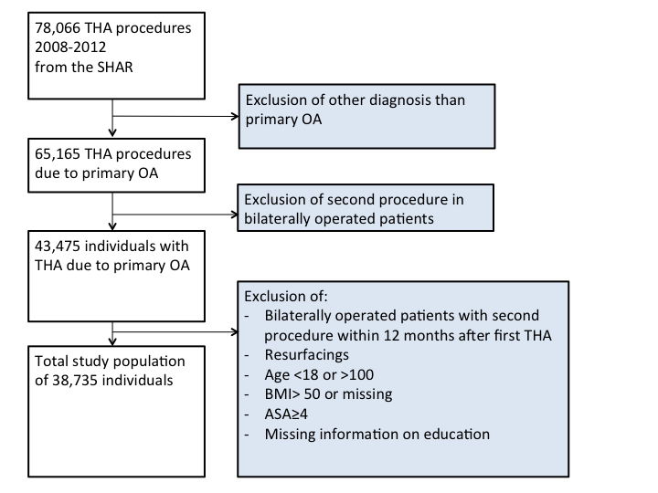

**Figure 2:** ROC for the investigated comorbidity measures: Age, gender, ASA, presence of heart infarction and renal disease during the last 12 months, ASA alone, CCI, Elixhauser and RxRiskV.

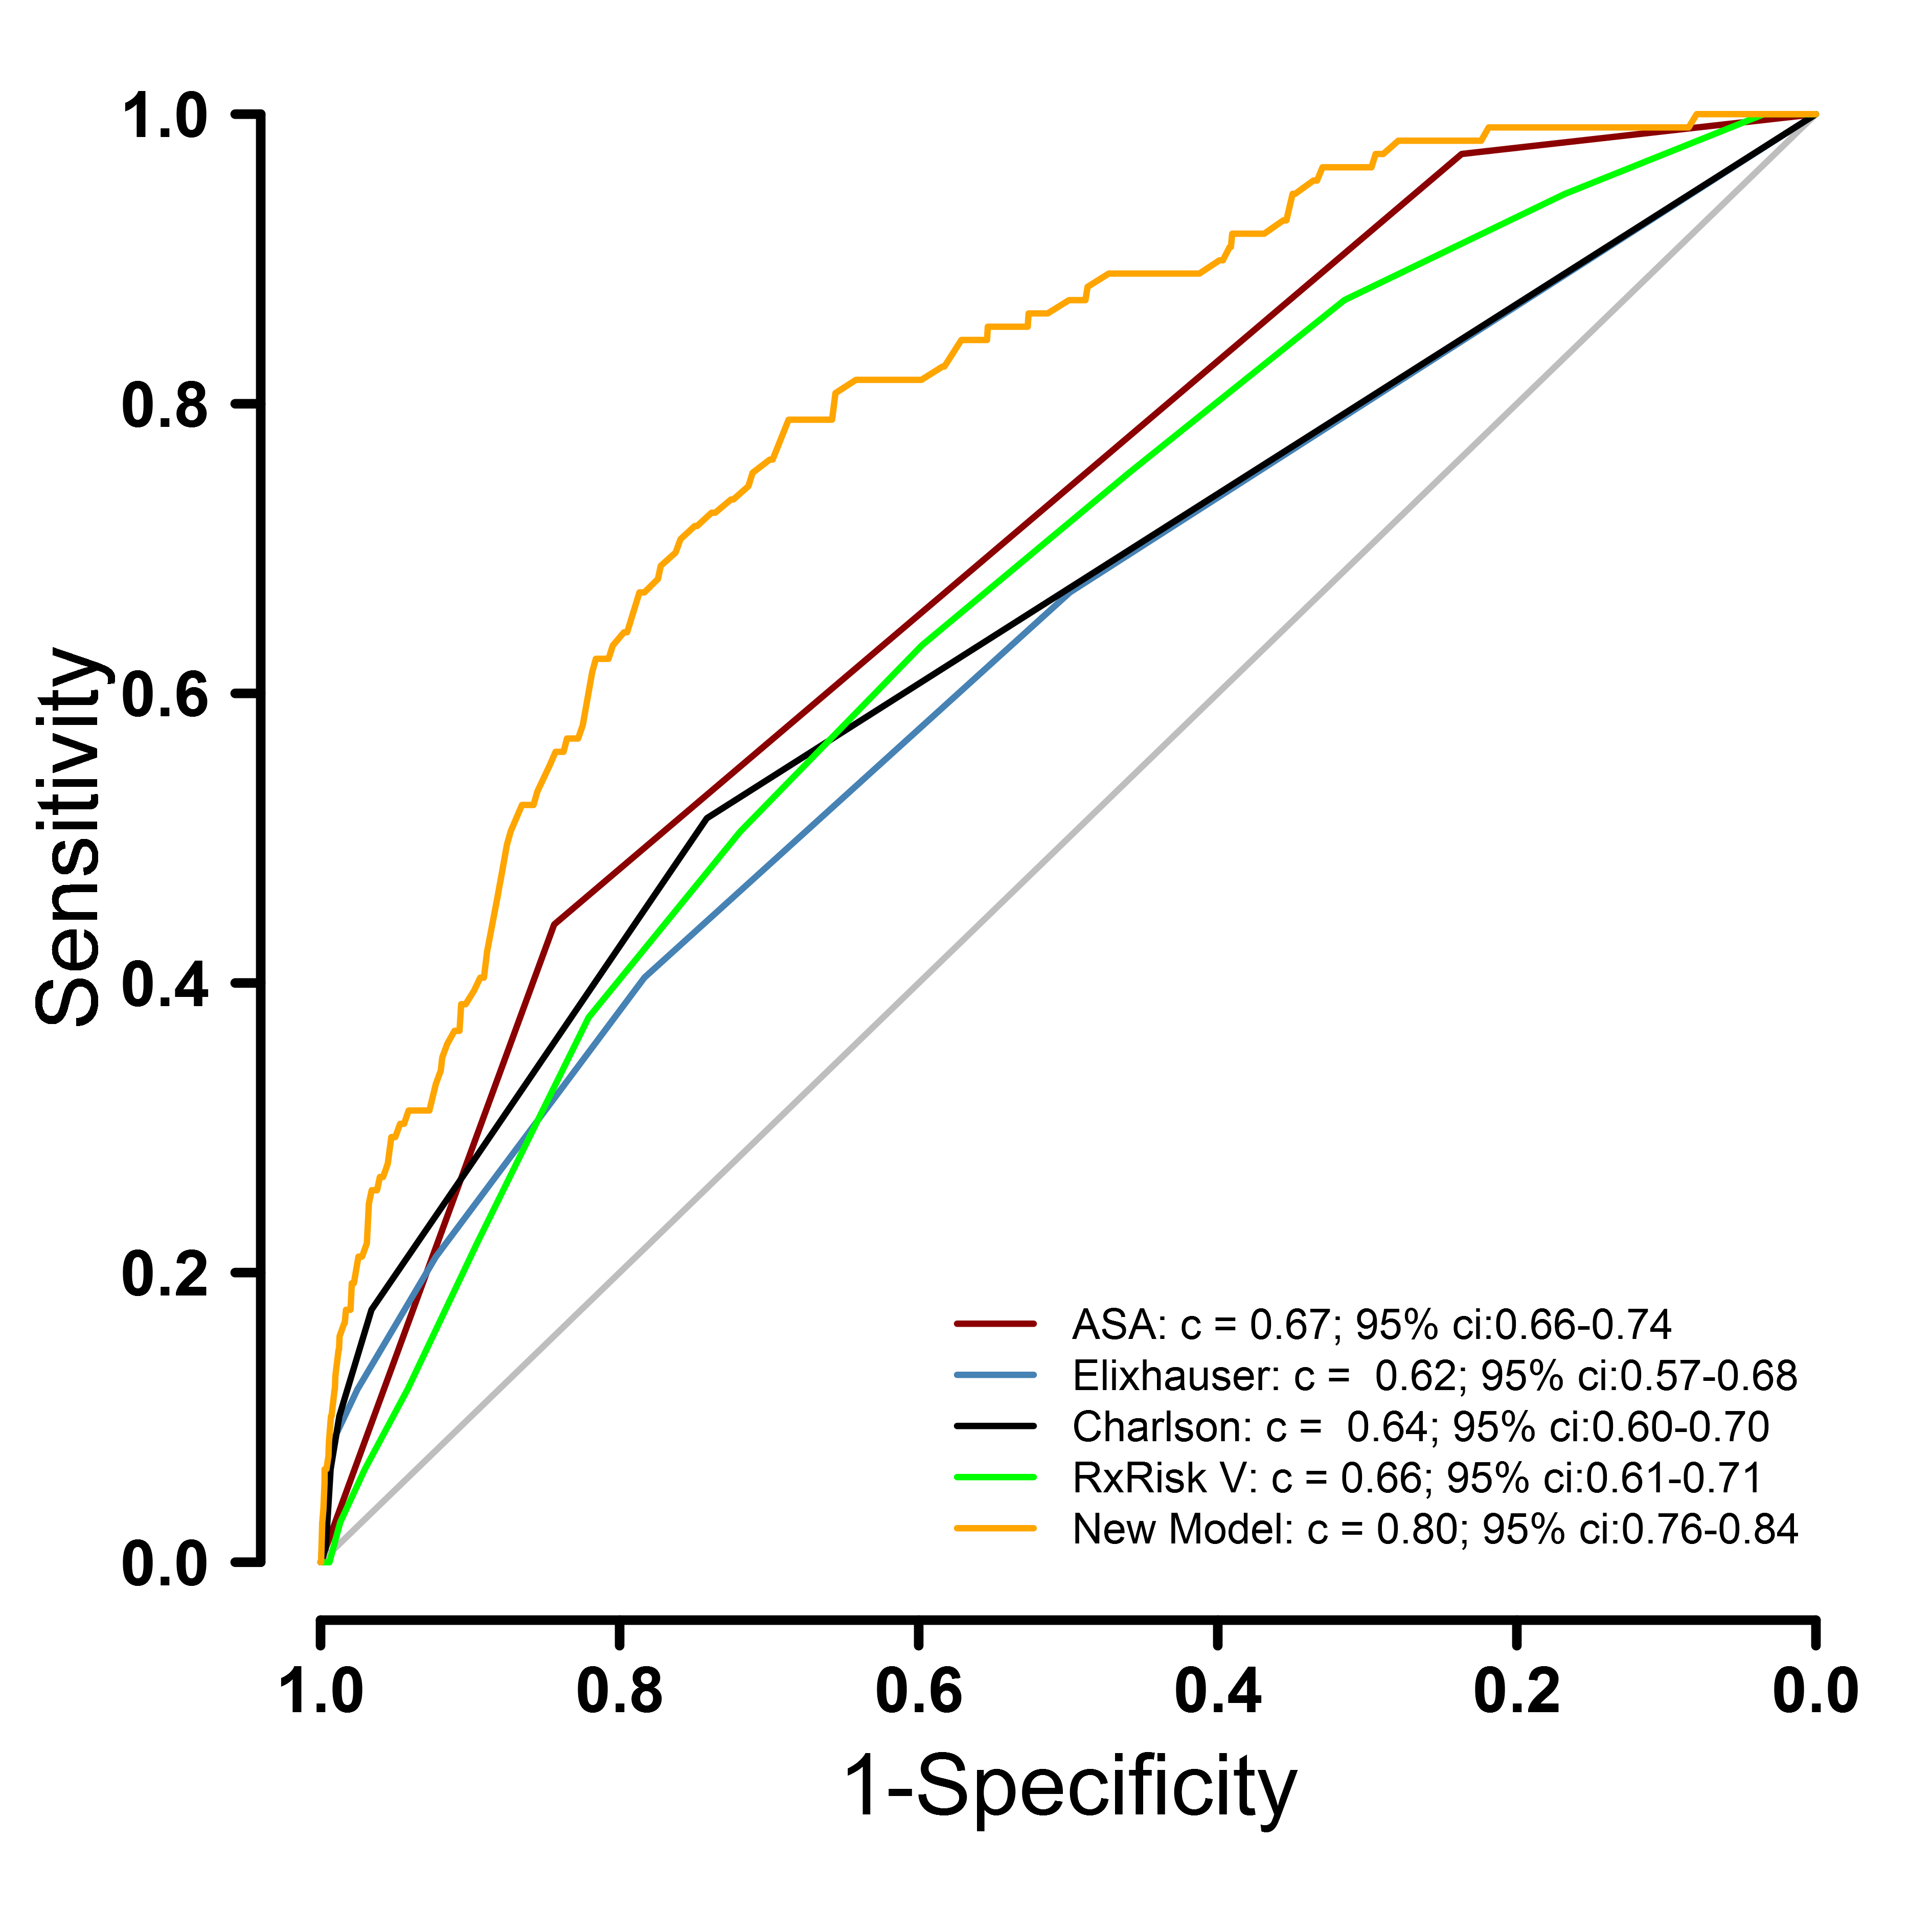

**Supplementary Table 1:** OR for mortality 90 days and one year after THA for a model combining age, gender, ASA, BMI, presence of heart infarction and renal disease during the last 12 months.

|  |  |  |  |  |
| --- | --- | --- | --- | --- |
|  | **90-day** | | **One-year** | |
|  | **OR** | **CI (95%)** | **OR** | **CI (95%)** |
|  |  |  |  |  |
| **Age** | 1.1 | 1.06-1.12 | 1.1 | 1.06-1.1 |
| **Gender[1]** |  |  |  |  |
| Female | 0.5 | 0.32-0.70 | 0.6 | 0.45-0.69 |
| **ASA[2]** |  |  |  |  |
| 2 | 3.6 | 1.10-11.86 | 1.7 | 1.11-2.68 |
| 3 | 6.8 | 2.00-23.37 | 3.5 | 2.15-5.60 |
| **BMI** | 1.0 | 0.95-1.04 | 1.0 | 0.95-1.00 |
| **Heart infarction** | 1.7 | 1.06-2.60 | 1.1 | 0.87-1.42 |
| **Renal disease** | 3.4 | 1.66-6.93 | 3.0 | 1.89-4.87 |

|  |  |  |
| --- | --- | --- |
|  |  |  |

**Supplementary Figure 1:** ROC for 90-day and one-year mortality for age, gender, ASA, presence of heart infarction and renal disease during the last 12 months combined.

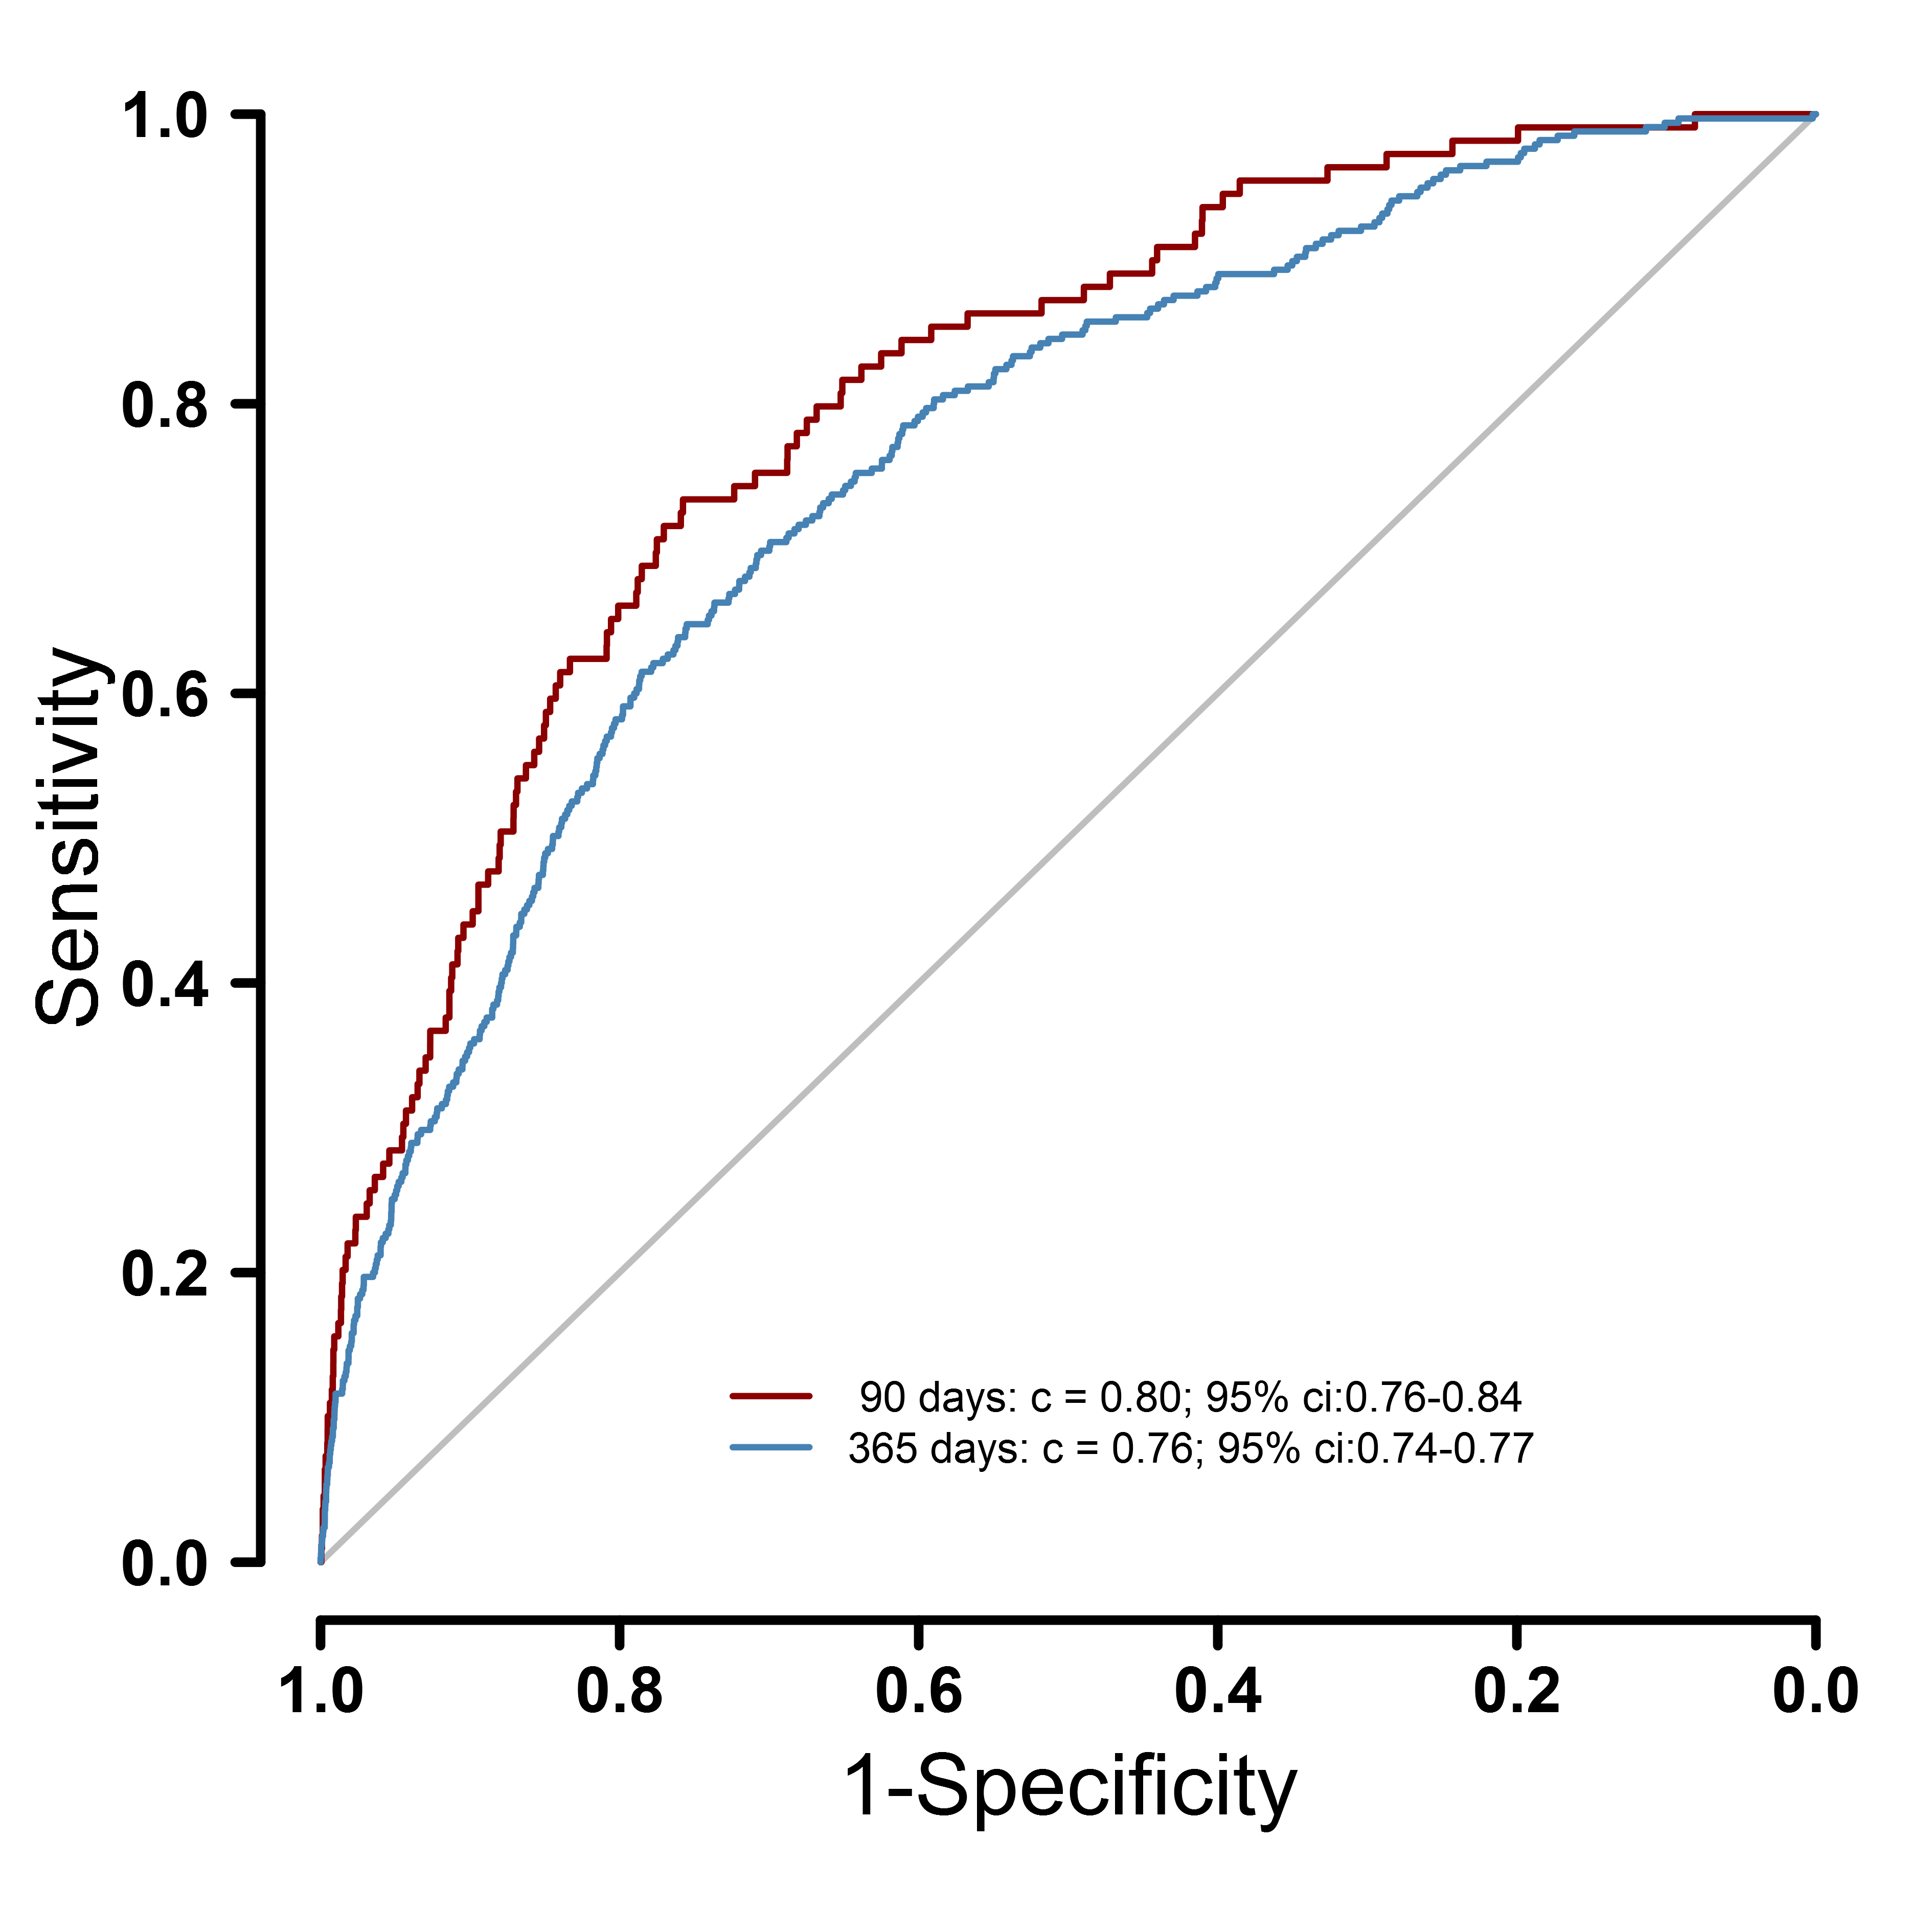

**Supplementary Table 2:** One-year mortality OR with 95% CI and c- statistics for the three investigated coding algorithms and their included dimensions. A) Elixhauser Score, B) Charlson Comorbidity Index and C) RxRiskV. When no patients have been registered it is marked with “-“ and calculation of OR and CI (95%) is not meaningful.





**C:**

|  |  |  |  |
| --- | --- | --- | --- |
| **RxRiskV** | **OR** | **CI (95%)** | **c-statistic** |
|  |  |  |  |
| Alcohol dependence | 1.76 | 0.43-7.14 | 0.50 |
| Allergies | 0.59 | 0.52-1.12 | 0.51 |
| Anti coagulation therapy | 1.8 | 1.29-2.44 | 0.53 |
| Anti platelet therapy | 1.7 | 1.34-2.12 | 0.55 |
| Anxiety | 1.9 | 1.35-2.62 | 0.53 |
| Arrhythmia | 2.3 | 1.32-3.90 | 0.51 |
| Benign prostate hypertrophy | 1.8 | 1.07-2.96 | 0.51 |
| Bipolar disorder | 1.6 | 0.87-2.91 | 0.51 |
| Chronic heart failure | 1.8 | 1.47-2.61 | 0.57 |
| Dementia | - | - | 0.50 |
| Depression | 1.1 | 0.83-1.54 | 0.51 |
| Diabetes | 1.8 | 1.29-2.41 | 0.53 |
| End stage renal disease | 9.8 | 5.72-16.79 | 0.52 |
| Epilepsy | 2.2 | 1.28-3.63 | 0.51 |
| Gastric oesophageal reflux disorder | 1.3 | 1.01-1.63 | 0.52 |
| Glaucoma | 1.2 | 0.72-1.87 | 0.50 |
| Gout | 2.5 | 1.61-4.02 | 0.52 |
| Hepatitis C | 1.2 | 0.48-2.86 | 0.50 |
| HIV | 15.8 | 3.57-69.61 | 0.50 |
| Hyperkalaemia | - | - | 0.50 |
| Hyperlipidaemia | 1.5 | 1.17-1.84 | 0.54 |
| Hypertension | 1.6 | 1.25-1.93 | 0.55 |
| Hyperthyroidism | 0.9 | 0.57-1.27 | 0.51 |
| Angina | 2.8 | 2.09-3.83 | 0.55 |
| Ischaemic heart disease hypertension | 2.1 | 1.66-2.57 | 0.59 |
| Inflammatory bowel disease | 2.4 | 1.13-5.15 | 0.51 |
| Liver failure | 3.0 | 2.15-4.33 | 0.54 |
| Malignancies | 5.8 | 2.83-11.93 | 0.51 |
| Malnutrition | - | - | 0.50 |
| Migraine | 0.3 | 0.05-2.33 | 0.50 |
| Osteoporosis Paget’s | 1.7 | 1.13-2.61 | 0.51 |
| Pain | 1.4 | 1.09-1.68 | 0.54 |
| Inflammation pain | 0.4 | 0.32-0.49 | 0.61 |
| Pancreatic insufficiency | 2.1 | 0.51-8.45 | 0.50 |
| Parkinson’s disease | 1.8 | 0.98-3.13 | 0.51 |
| Psoriasis | 0.7 | 0.17-2.70 | 0.50 |
| Psychotic illness | 1.9 | 0.89-4.00 | 0.51 |
| Chronic airways disease | 1.1 | 0.79-1.57 | 0.51 |
| Smoking cessation | 0.4 | 0.05-2.71 | 0.50 |
| Steroid responsive diseases | 1.5 | 1.10-2.05 | 0.52 |
| Transplant | - | - | 0.50 |
| Tuberculosis | - | - | 0.50 |
| RxRiskV index | 1.2 | 1.12-1.21 | 0.62 |

1. Ref. = male
2. Ref.= 1